sudo apt-add-repository ppa:ansible/ansible

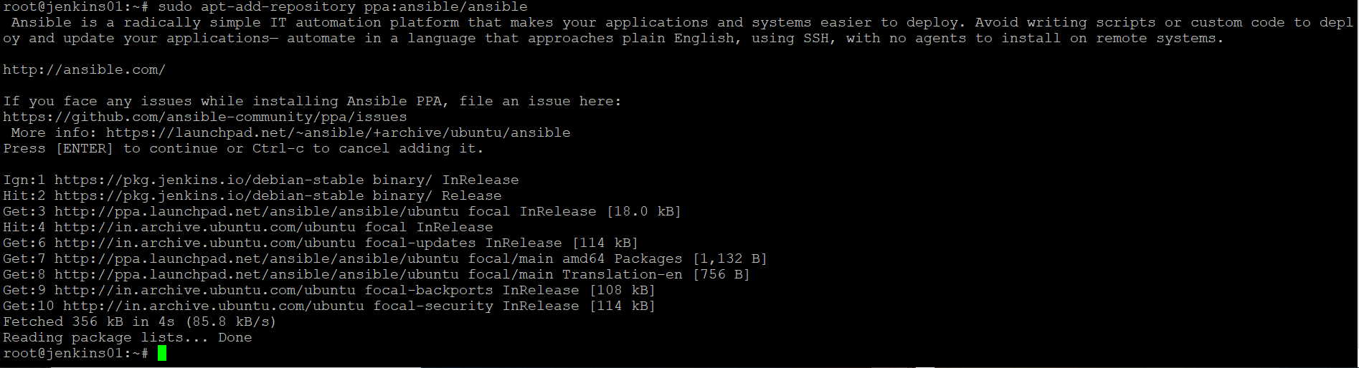

sudo apt update

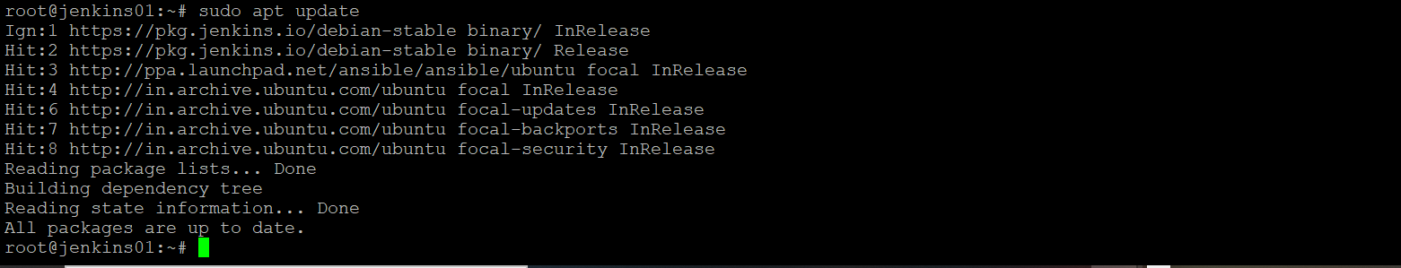

apt-get install ansible

